Societies Executive Committee Meeting 9 Minutes
20/12/23
- Welcome and Apologies
Justyna Kardasz (VP Community) – chair
Jamie Campbell – present
Jo Fitzpatrick – present
Cameron Pattinson – present
Karen Low – present
Ollie Page – present
Shania Maritz – apologies
Natalie Brayshaw (Activities Coordinator) – present
Erin Ross (Activities Coordinator) – clerk

Welcome to our new Activities Coordinator Natalie – ran through introductions and each member’s society category

- Approve Minutes from Societies Exec 8
Approved

- Matters Arising
- Part-Time and Distance Students in Societies
Socs staff will hold a drop-in sessions for new and returning students and socs on Fri 12th January, 12-2pm. Socs Exec are encouraged to attend in part if they are able – staff to invite Socs Exec
As part of January welcome acitivites, we are encouraging societies to introduce themselves online and to consider putting on digital/hybrid events - JF made a promo video about this and JK will make a social media post
Staff will send an email out to committee members about this before the break
- Charity Month
Landing-page on website is ready to go – exec approves
Socs Exec filmed content with Comms – this will go out in January
Staff to confirm process for societies that Socs Exec members are part of
- Grant Guidance
Finance information has been improved this semester with a landing-page (https://www.strathunion.com/organisation/resources/finances/) where the finance training content is permanently available as a resource for students
Socs team are now working on improving grant information with a landing-page (https://www.strathunion.com/organisation/resources/grants/), separate grant training module and improved grant guidelines
Thank you from the staff team to Socs Exec for collaborating so well with us this semester on these resources and projects to help societies!

- Budget Update

 | Arts and Culture | General Pot
Start of year | £15,000 | £40,000
After Exec 1 | £14,410 | £38,785.26
After Exec 2 | £12,964.82 | £38,135.26
After Exec 3 | £10,324.82 | £36,328.79
After Exec 4 | £9780.77 | £35,233.79
After Exec 5 | £9580.77 | £34,797.26
After Exec 6 | £6957.08 | £30,723.79
After Exec 7 | £4930.68 | £28,528.88
After Exec 8 | £4930.68 | £27,836.10

Funding Breakdowns – Semester 1:
Note: Numbers in the chart represent the % of the total amount in that pot. The first chart “% of total funding awarded” includes both the general pot and the arts and culture funding. Total = £55,000. So if a society had received 5% of total funding, that would be 5% of £55,000 (= £2750). There are also charts to show the spent in each pot respectively. Societies with <1% of the funding are not included in the charts. The charts do not add to 100 as the entire pot has not yet been spent.
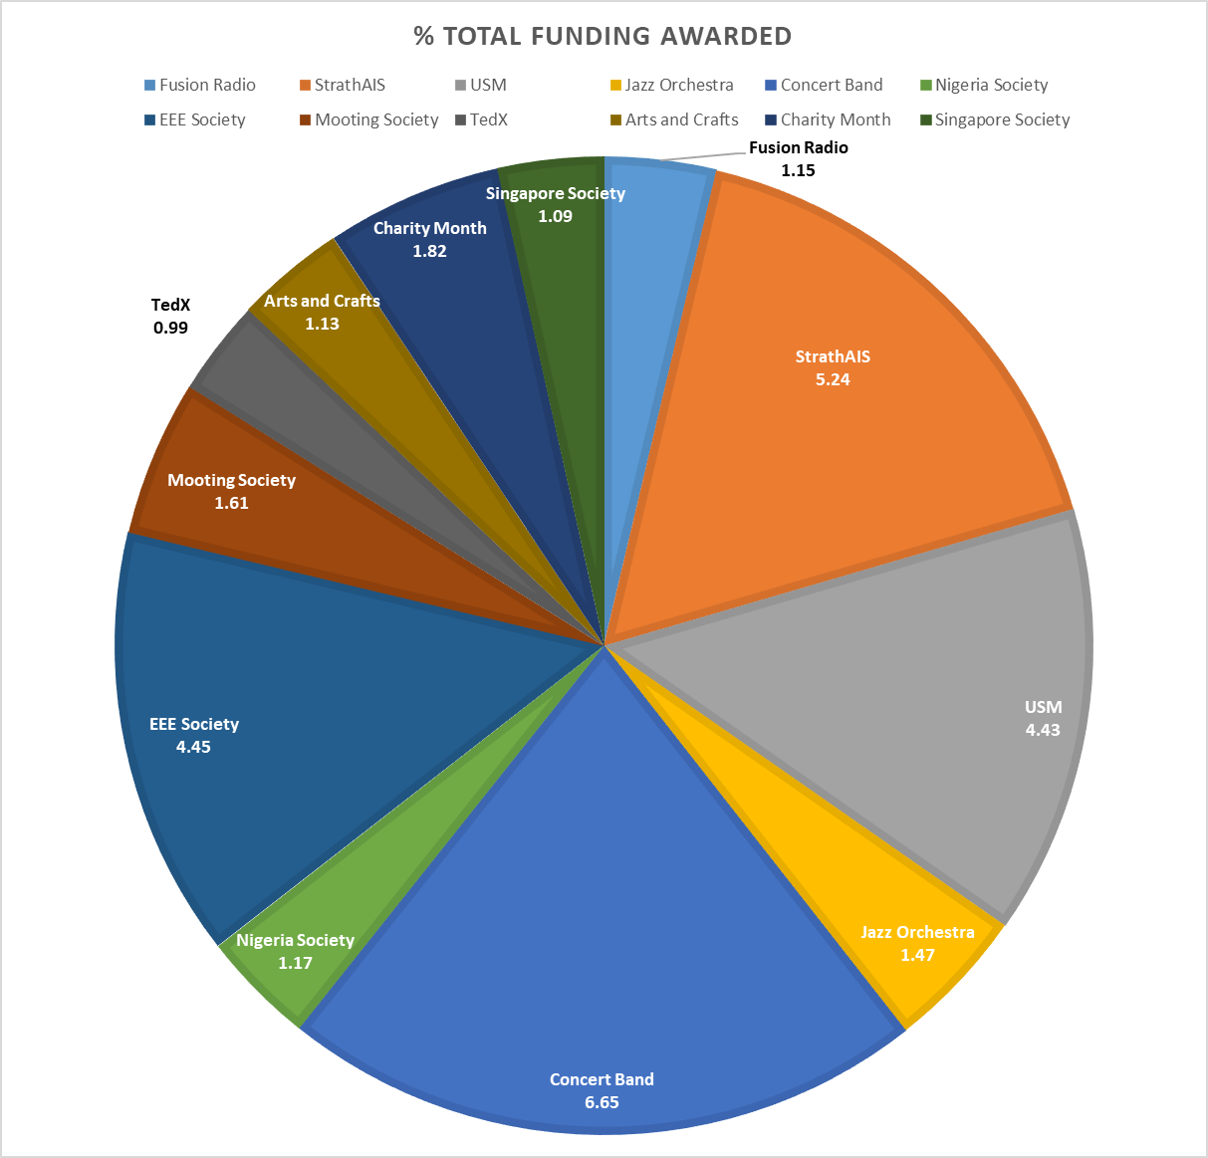
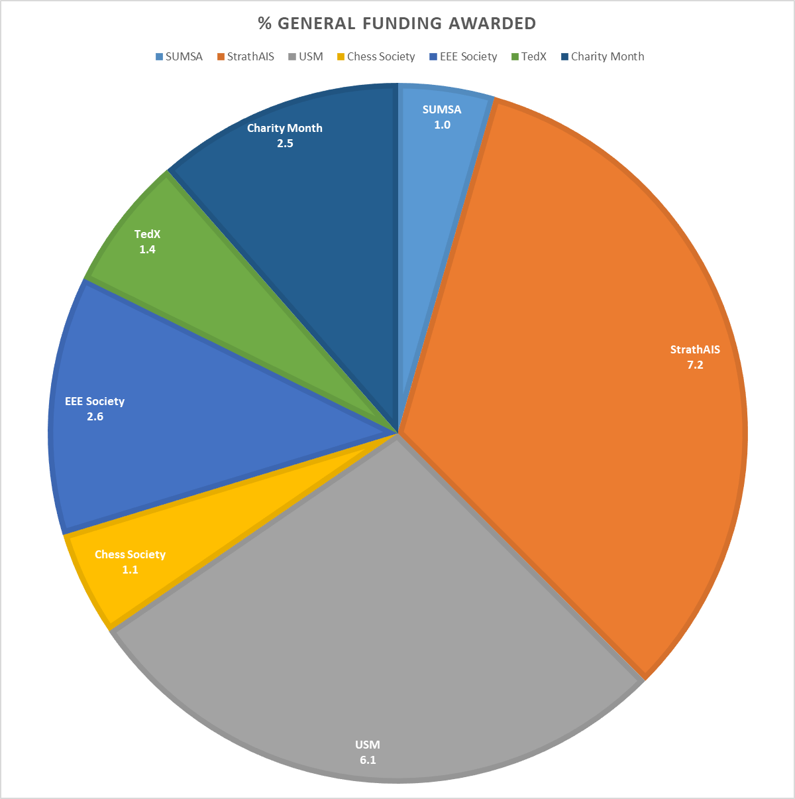
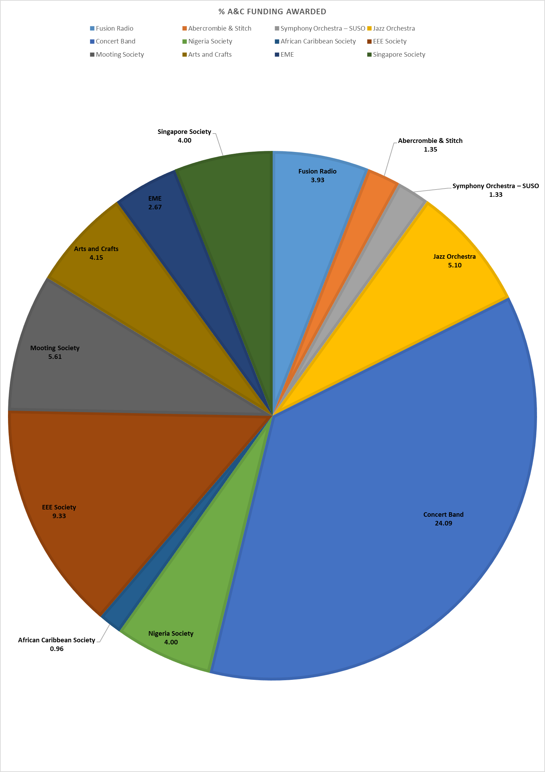

Exec members note that this is not as diverse a spread of societies as it could be
Compared with the figures at the end of 2022/23, the societies that secured the lion’s share of funding this time corresponds roughly to large active societies undertaking major events and initiatives
The lion’s share also does not clearly correspond to societies that members themselves are involved in
An exception is Concert Band being awarded most Arts and Culture funding – but this is not extraordinary as it is mostly the music societies who make use of this fund

- Welcome Grants (£45). Total: £135

  - Strathclyde Trading Society (this should have been approved in Exec 2, but missing from minutes)
  - USEV (should have been approved already, missing from minutes)
  - Engineers with Beers (should have been approved already, missing from minutes)

- Grant Requests. Total: £429.66

- Travel Society – Anne Frank House Visit (Grant #1543)
  - Requested: £250 (53% - 75%)
  - Expected Income: £83.36
  - Total Budget: £333.36 - £473.44
  - Members: 363
This is retrospective so can’t be awarded – they are away right now
Always apply for the maximum you would like! Otherwise it’s hard to put numbers to this application (hence the unusual funding ‘bracket’ presented above) which the exec needs to evaluate it
Otherwise this is a strong application – exec urges society to apply for their next trip but well in advance! Do you have an upcoming trip planned? Exec can support you to make a strong application in good time
Staff also note this society has not completed the mandatory finance training which would help
Not approved

- Jazz Orchestra – Sheet Music (Grant #1550)
  - Requested: £179.66 (100%)
  - Expected Income: £0
  - Total Budget: £179.66
  - Members: 79
Great job including evidence of background costs for sheet music – exec notes society has taken on feedback from their last application and thanks them
KL notes that we would like to see part-funding – ER acknowledges this is part of a wider conversation the union needs to have with music societies about their funding needs
Happy to approve

- AOCB
Arts & Culture – exec notes that this university fund has not been topped up since it was set up. Staff confirm this will be requested next semester
Union staff are meeting this week to establish next steps in updating Arts & Culture funding
KL offers help with evidence from music socs if needed

JK and exec are going to make Societies FAQ podcasts next semester – JK notes points to cover:
- Grant guidance, including the amounts in the different pots
- Expand on part-funding
- Expand on why we can’t give retrospective funding and how to plan for this
- Committee member election – messaging about how societies can rectify their committee process now – not wait til next year!
 | Arts and Culture | General Pot
Start of year | £15,000 | £40,000
After Exec 1 | £14,410 | £38,785.26
After Exec 2 | £12,964.82 | £38,135.26
After Exec 3 | £10,324.82 | £36,328.79
After Exec 4 | £9780.77 | £35,233.79
After Exec 5 | £9580.77 | £34,797.26
After Exec 6 | £6957.08 | £30,723.79
After Exec 7 | £4930.68 | £28,528.88
After Exec 8 | £4930.68 | £27,836.10
After Exec 9 | £4751.02 | £27,691.10

