Black Students’ Winter Conference 2018
Strathclyde Delegate Report by Abayomi Alli ‎
Date & Conference Agenda
The conference took place on the 24th and 25th of November 2018 and it’s a two day event which gives delegates of African, Arab, Asian and Caribbean descent a platform to take part in various workshops and hear and learn from the experiences of key leaders within the BME community.

Summary
The conference started with a plenary session titled “Decolonising Education – Dismantling racist structures at our institutions” given by Lola Olufemi, an English graduate of the University of Cambridge. The plenary basically discusses the challenges of integrating black history into the curriculum and one important challenge is that there is no one to teach it.
This was followed by the second plenary session titled “Race for Equality consultation – shape our new research on Black students’ experiences in education.
Altogether, there were 7 plenary sessions of which we were only able to attend 6 due to the time of our train
Delegates were also treated to a variety of workshops including My racist campus, Conversation booth, Drugs and race, Youth violence and Climate change is a race issue.

Highlights
- One of the main highlights for me was the drugs and race workshop which was anchored by Imani Robinson which opened by eyes on the misconception of drugs.

What would you like to take forward? / What did you take away?
Mental health for black students is one area which is often disregarded due to various reasons in the black community. It may be because a lot of Africans don’t recognise it, they regard it as a taboo or it is considered as bringing shame to the family name. The main issue with mental health is awareness and I think it is a good place to start.
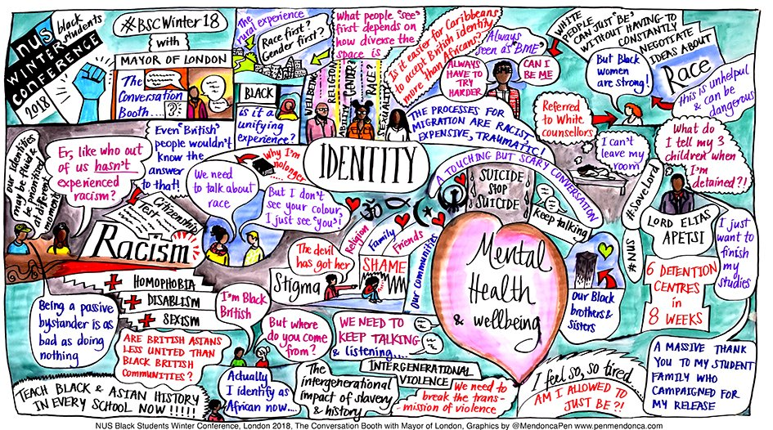

What connections, learnings did you take from Conference and how can you realise them at Strathclyde?
Hearing some stories during the third plenary session which was “Engaging with students union – highlighting the racism we face in our roles and how we can challenge” and it occurred that these other schools actually have it worse and the system works in Strathclyde.

What is an issue Strathclyde Students’ of African, Asian, Caribbean, Arab, First Nation and Latinx descent should know about – what is the conversation among Black Students nationally?
One issue that the minority groups should know about is mental health. A lot of these communities do not want to talk about mental health because they believe such does not exist and should not be spoken about. Also, when a certain individual has a problem, because he is used to community telling him not to talk about such, he keeps to himself.

